**ASSIGNMENTS ON DIGITAL MARKETING**

**NAME:** A.DHIVYA

**DEPARTMENT:** BIO MEDICAL ENGINEERING

**COLLEGE:**8151 DHANALAKSHMI SRINIVASAN INSTITUTE OF TECHNOLOGY

**NAANMUDHALVAN COURSE:** DIGITAL MARKETING

**NM ID:**769F95872FE4282869C4E22439F8A5FC

**ASSIGNMENT 1:**

Create a blog or website using blogspot and WordPress .Customize the theme design and post new article with 500 words.

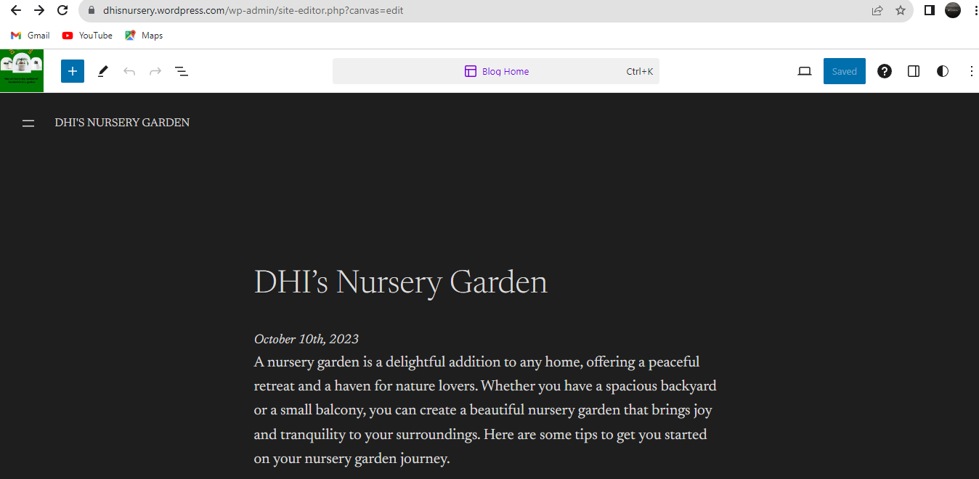

WORDPRESS LINK: <https://wordpress.com/post/dhisnursery.wordpress.com>

BLOGSPOT: <https://dhisnursery.blogspot.com/2023/09/infographics-dhis-nursery-garden.html>

**ASSIGNMENT 2:**

create a new Facebook business page and post one social media poster for your

brand.

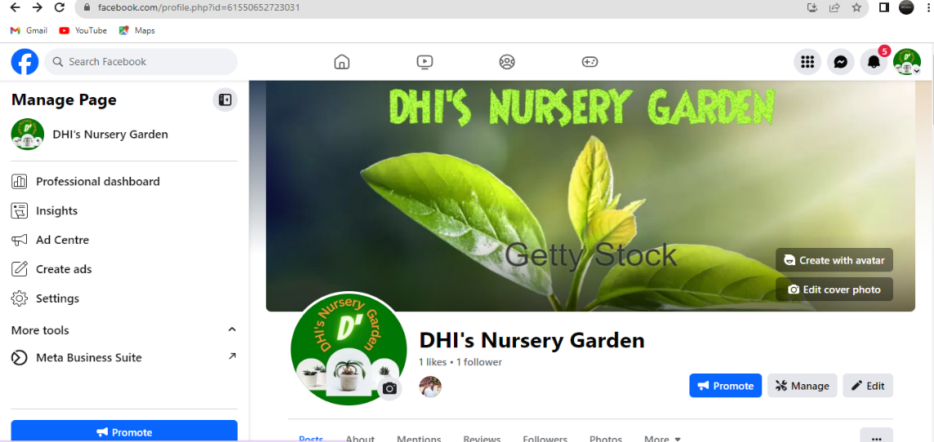

LINK: LINK: <https://www.facebook.com/profile.php?id=61550652723031>

**ASSIGNMENT 3:**

Create and design a social media advertisement poster using Canva.



**ASSIGNMENT 4:**

Create email newsletter design using MailChimp or Canva tool.

